**Comment 1 -** There should be at least one test for the express server and application javascript

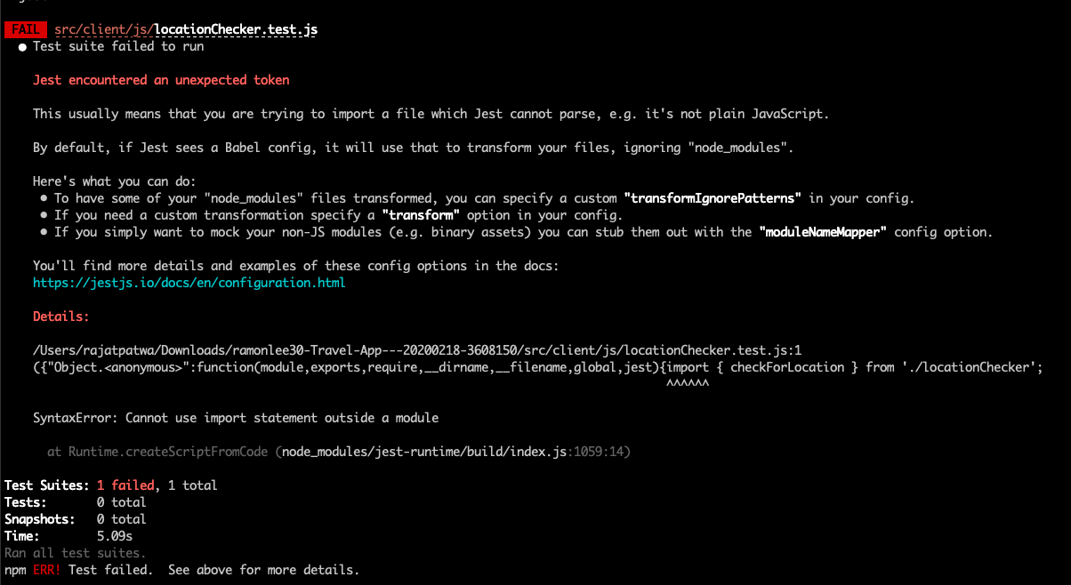

**Comment 2 - Styling is set up in a logical way. All interactive elements have hover states.**

* **There is an issue here. The CSS files are not getting compiled. See image below.**
* **This is because you are using CSS syntax in scss file. Try renaming the SCSS files to CSS extension.**

